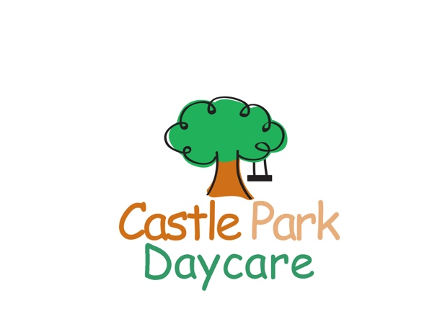
Activity Camp 2021
9am-4pm
Ages 6 and up
www.castleparkdaycare.ca
416 691-5211
1971 Queen St. E. Suite 102, Toronto, Ontario M4L 1H9

Camper’s First Name: _______________________________ Last Name _________________________M ____ F

Birth date: _____/__________/_________ grade _______ School: __________________________________________

Address: _________________________________________________________________________________________
Street City Postal Code

Parent Name: _________________________________________________Cell # (______)____________________

Work: ( ________)_______________________ e-mail ___________________________________________________

Emergency contact: __________________________________________ Relationship: __________________________

Work #: (_____)__________________________________ Cell #: (______)____________________________________

Authorized pick up: 1) ___________________________________ Relationship: ________________________________

2) ___________________________________ Relationship: ________________________________

Allergies: ________________________________________________________________________________________
Please fill out anaphylactic form if needed (please ask staff)

Physician’s name:______________________________________ Phone # :_______________________________

Health card #: ________________________________________________
Week 1 |  | Week 2 |  | Week 3 | Week 4 | Week 5 |  | Week 6 |  | Week 7 |  | Week 8 |  | Week 9
Science |  | Arts and craft |  | Outdoor Adventure | Lego | Water Fun |  | Sports Camp |  | Creative Drama |  | Closed |  | Let’s have Fun
July 3-9 | July 12-16 |  | July 19-23 |  | July 26-30 | Aug.3-6 | Aug.9-13 |  | Aug 16-20 |  | Aug.23-27 |  | Aug.30-Sept.3
$220 | $220 |  | $220 |  | $220 | $180 | $220 |  | $220 |  | Closed |  | $220
* | * |  | * |  | * | * | * * |  | * |  | * |  | *

*extended care is available for $50/week until 6pm. Please indicate with a 2nd check mark.

Payment: $50 non-refundable deposit required with registration and remaining balance due by July 1st. Pay by cash, cheque or e-transfer. Please make cheque payable to: Castle Park Daycare E-mail for e-transfer: edembeck22@gmail.com

I have included: cash Cheque e-transfer

Amount: $ _____________________

