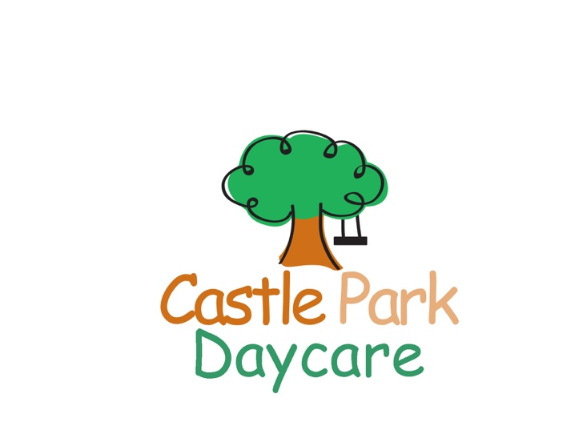
Variety Camp 2020
Half day 9am-12pm
416 691-5211
www.castleparkdaycare.ca

1971 Queen St. E. Suite 102, Toronto, Ontario M4L 1H9

Camper’s Name: ____________________________________________________________ M ____ F ____

Birth date: _________________________ grade _______ School: ____________________________________

Address: __________________________________________________________________________________
Street City Postal Code

Parent 1 Name: _______________________________________ Parent 2 Name: _________________________________________

Home # _____________________________________ Home # ______________________________________

E-mail: _______________________________________ E-mail: _____________________________________

Cell #: (_____)_________________________________ Cell #: (______)________________________________

Address:_____________________________________ Address:______________________________________

Emergency Contact: _________________________________ Relationship: _____________________________

Contact Phone: __________________________________ Cell Phone: _________________________________

Allergies:

Health card #: ________________________________________________________________________________________

Physician Name: _______________________________________ Phone #:
Week 1 | Week 2 | Week 3 | Week 4 | Week 5 | Week 6 | Week 7 | Week 8 | Week 9 | Week 10
*June 29-July 3 | July 6-10 | July 13-17 | July 20-24 | July 27-31 | Aug. 3-7* | Aug 10-14 | Aug.17-21 | Aug.24-28 | Aug.31-Sept.3
$90 | $120 | $120 | $120 | $120 | $90 | $120 | $120 | Closed | $120
 |  |  |  |  | * | * | *

*extended care is available for $50/week until 6pm. Please indicate with a 2nd check mar

Payment: $50 non-refundable deposit required with registration and remaining balance due by July 1st. Pay by cash, cheque or e-transfer. Please make cheque payable to: Castle Park Daycare. E-mail for e-transfer: edembeck@bellnet.ca.

I have included: cash Cheque e-transfer
Amount: $ _____________________

